Akdeniz University

Department of Computer Engineering

Software Engineering Project

Project short-name: project title

Software Requirements Specification

*Hümerya Polat*

*Hümeyra Köseoğlu*

*Furkan Can Tavukçu*

*Muhammed Mazlum Orhan*

**Team Leader:** Furkan Can Tavukçu

**Product Owner:** Team

**Instructor:** Prof. Ümit Deniz ULUŞAR

12/03/2022

This report is submitted to the Department of Computer Engineering of Akdeniz University of the Software Engineering course CSE332.

|  |  |
| --- | --- |
| **Abbreviations** | |
| IP | Internet Protocol |
|  |  |
|  |  |
|  |  |
|  |  |
|  |  |
|  |  |
|  |  |
|  |  |
|  |  |
|  |  |
|  |  |
|  |  |
|  |  |
|  |  |
|  |  |
|  |  |
|  |  |
|  |  |
|  |  |
|  |  |
|  |  |

Contents

1 Introduction 1

1.1 Purpose 1

1.2 Product Scope 1

1.3 References 1

2 Overall Description 1

2.1 Product Perspective 1

2.2 Product Functions 1

2.3 User Classes and Characteristics 1

2.4 Operating Environment 1

2.5 Design and Implementation Constraints 1

2.6 User Documentation 2

2.7 Assumptions and Dependencies 2

3 External Interface Requirements 2

3.1 User Interfaces 2

3.2 Hardware Interfaces 2

3.3 Software Interfaces 2

3.4 Communications Interfaces 2

4 System Features 2

4.1 System Feature 1 2

4.1.1 Description and Priority 2

4.1.2 Stimulus/Response Sequences 2

4.1.3 Functional Requirements 3

4.2 System Feature 2 (and so on) 3

5 Use Cases 3

5.1 Creating an new account 3

5.2 Deleting an account 3

6 Nonfunctional System Requirements 4

6.1 Performance Requirements 4

6.2 Safety Requirements 4

6.3 Security Requirements 4

6.4 Software Quality Attributes 4

6.5 Business Rules 4

7 Other Requirements 4

8 Proposed System 5

8.1 Overview 5

8.2 Functional Requirements 5

8.3 Non-functional Requirements 5

8.4 Pseudo Requirements 6

8.5 System Models 6

8.5.1 Scenarios 6

8.5.1.1. Patient and Doctor Member of the System 6

8.5.2 Use-Case Model 6

8.5.3 Object and Class Model 6

8.5.4 Dynamic Models 7

8.5.5 User Interface 7

8.5.6 Test 7

9 References 7

10 Appendix A: Glossary 7

# Introduction

## Purpose

<Identify the product whose software requirements are specified in this document, including the revision or release number. Describe the scope of the product that is covered by this SRS, particularly if this SRS describes only part of the system or a single subsystem.>

The purpose of the this document is to explain the requirements of the our application. You’ll find answer for system structure, application constraints, user interface and Intecration between entities. This document is to be demonstrated for the customer’s approval or a reference for further development.

## Product Scope

<Provide a short description of the software being specified and its purpose, including relevant benefits, objectives, and goals. Relate the software to corporate goals or business strategies. If a separate vision and scope document is available, refer to it rather than duplicating its contents here.>

The “Resfebe” is a mobile application which helps people to combines the illustrated pictures with individual letters to depict words and/or phrases. The application will be free to download from either a mobile phone application store or similar services.

Players will provide their info for the registration. An administrator will use the web-portal in order to administer the system and monitor player activities.

Furthermore, the software needs Internet connection to fetch and display results. All system information is maintained in a database, which is located on a web-server. The software also interacts with the mobile phones ……… softre which is required to be an already installed application on the user’s mobile phone. By using the mobile application, users can view …... The application also has the capability of representing both summary and detailed information about the top scorers..

The [NameOfApp] is protect people from cancel culture. The toxicity of cancel culture destroyed thoudns of people life, they had to leave their job, school and their city but these are may have been luckiest ones , cause lots of people couldn’t take it, attempt suicide and many of them died. The new are of Cancel Culture continue to destroy Celebrities because of something that they said 10 years ago. Kevin Hurt – the most successful stand-up comedian judged by some twits which he published almost 10 ago. Last Year , Kevin were hosting Oscars and that was the beginning of everything. The haters just dig down 10 years and find some joke about “Gay People” and they made pressure on concuil of Oscars to get hosting from kevin. And they did. They got the change of hosting from Kevin. Could you image that? Today we saying something and 10 years later someone find them hey , you said this so you can’t do this now. If wish I were told you a fantastic story but this happened in the lasy years. And It continues to happen . Toxic people abusing freedom of speech. We are going to let people to say things anonymously to protect them. People will be able socialize as usual but when they want to say something and if they aren’t comfortable with they will able to publish their thoughts anonymously.

## References

<List any other documents or Web addresses to which this SRS refers. These may include user interface style guides, contracts, standards, system requirements specifications, use case documents, or a vision and scope document. Provide enough information so that the reader could access a copy of each reference, including title, author, version number, date, and source or location.>

# Overall Description

## Product Perspective

<Describe the context and origin of the product being specified in this SRS. For example, state whether this product is a follow-on member of a product family, a replacement for certain existing systems, or a new, self-contained product. If the SRS defines a component of a larger system, relate the requirements of the larger system to the functionality of this software and identify interfaces between the two. A simple diagram that shows the major components of the overall system, subsystem interconnections, and external interfaces can be helpful.>

This system will consist of two parts: one mobile application and one web portal. The mobile application will be used to play the game and view the top scores while the web portal will be used for managing the information about the game and the system as a whole.

The mobile application will need to communicate to the server to download xxxxx and register the score. …

Since this is a data-centric product it will need somewhere to store the data. For that, a database will be used. Both the mobile application and web portal will communicate with the database, however in slightly different ways. The mobile application will only use the database to get data while the web portal will also add and modify data. All of the database communication will go over the Internet.

The mobile application has some restrictions about the resource allocation. To avoid problems with overloading the operating system the application is only allowed to use 20 megabytes of memory while running the application. The maximum amount of hard drive space is also 20 megabytes.

Our Application mainly made of 2 Parts:

1. Cross-platform Frontend UI
2. .Net Core backend

UI going to written in Flutter so Application will be available both on IOS and Android. We are going to use Flutter responsive utility to run Application also in Web Browsers. Frontend Communicate with backend on .Net core Web APIs . Data will be stored in PostgreSQL but in future this may change. If Application need Real time data follow , we are also planning to use Websockets.

Communication with Database will be established in backend and frontend won’t be able to communicate database directly no matter what. In our application Data Flow will be from Database to .Net Core then from there to Front-end or vice Versa.

<Summarize the major functions the product must perform or must let the user perform. Details will be provided in Section 3, so only a high level summary (such as a bullet list) is needed here. Organize the functions to make them understandable to any reader of the SRS. A picture of the major groups of related requirements and how they relate, such as a top level data flow diagram or object class diagram, is often effective.>

With the mobile application, the users will be able to search for games. The result will be based on the criteria the user inputs. There are several search criteria and it will be possible for the administrator of the system to manage the options for those criteria that have that.

The result of the search will be viewed in a list view, depending on what criteria included in the search. The list view will have one list item for each game matching the search criteria and show a small part of the game information so the user can identify the game. The users will be able to either select a game to play or get information top player scores, or view the information of a specific game.

The web portal will provide functionality to manage the system and the game information. It will also provide information about the system, for example show when there is a new update.

Frontend application will be written in Flutter and for All platforms it will preserve its functions. Some small changes may occur while we are developing Application like using webcam instead of phone camera, or disabling taking picture , etc.

* Users can share post
  + Image
  + Text
* Users can share post anonymously
* Users can follow other user
* Users can like and Comment on posts
* Users can modify their profile

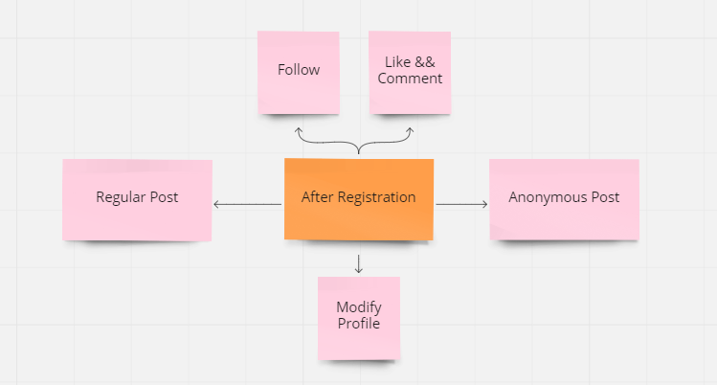

## User Types and Characteristics

<Identify the various user classes that you anticipate will use this product. User classes may be differentiated based on frequency of use, subset of product functions used, technical expertise, security or privilege levels, educational level, or experience. Describe the pertinent characteristics of each user class. Certain requirements may pertain only to certain user classes. Distinguish the most important user classes for this product from those who are less important to satisfy.>

There are three types of users that interact with the system: users of the mobile application, data providers and administrators. Each of these three types of users has different use of the system so each of them has their own requirements.

The mobile application users can only use the application to perform xxx. This means that the user have to be able to xxx, choose xxxx from that search and then xxxx. In order for the users to get a relevant search result there are multiple criteria the users can specify and all results matches all of those.

With the mobile application, the users will be able to search for games. The result will be based on the criteria the user inputs. There are several search criteria and it will be possible for the administrator of the system to manage the options for those criteria that have that.

The result of the search will be viewed in a list view, depending on what criteria included in the search. The list view will have one list item for each game matching the search criteria and show a small part of the game information so the user can identify the game. The users will be able to either select a game to play or get information top player scores, or view the information of a specific game.

The web portal will provide functionality to manage the system and the game information. It will also provide information about the system, for example show when there is a new update.

All registered user will have some properties and functionalities except Moderators, regular user will have all power about how to control their profile and management of posts which they shared. Moderators ( human or non-human) will identify undesired posts , comments and tag them with sensitive tags. If a user violate our policy consistently moderators will have rights to ban the user.

* User Types
  + Regular Users
    - Follow People
    - Like and Comment
    - Regular Post and Anonymous Post
    - Chat with other user
  + Moderators - Copes of Application
    - Watch Users’ public activities
    - Tag comments
    - Ban Users

## Operating Environment

<Describe the environment in which the software will operate, including the hardware platform, operating system and versions, and any other software components or applications with which it must peacefully coexist.>

## Design and Implementation Constraints

<Describe any items or issues that will limit the options available to the developers. These might include: corporate or regulatory policies; hardware limitations (timing requirements, memory requirements); interfaces to other applications; specific technologies, tools, and databases to be used; parallel operations; language requirements; communications protocols; security considerations; design conventions or programming standards (for example, if the customer’s organization will be responsible for maintaining the delivered software).>

The Internet connection is also a constraint for the application. Since the application fetches data from the database over the Internet, it is crucial that there is an Internet connection for the application to function.

Both the web portal and the mobile application will be constrained by the capacity of the database. Since the database is shared between both application it may be forced to queue incoming requests and therefor increase the time it takes to fetch data.

## User Documentation

<List the user documentation components (such as user manuals, on-line help, and tutorials) that will be delivered along with the software. Identify any known user documentation delivery formats or standards.>

## Assumptions and Dependencies

<List any assumed factors (as opposed to known facts) that could affect the requirements stated in the SRS. These could include third-party or commercial components that you plan to use, issues around the development or operating environment, or constraints. The project could be affected if these assumptions are incorrect, are not shared, or change. Also identify any dependencies the project has on external factors, such as software components that you intend to reuse from another project, unless they are already documented elsewhere (for example, in the vision and scope document or the project plan).>

One assumption about the product is that it will always be used on mobile phones that have enough performance. If the phone does not have enough hardware resources available for the application, for example the users might have allocated them with other applications, there may be scenarios where the application does not work as intended or even at all.

# External Interface Requirements

## User Interfaces

<Describe the logical characteristics of each interface between the software product and the users. This may include sample screen images, any GUI standards or product family style guides that are to be followed, screen layout constraints, standard buttons and functions (e.g., help) that will appear on every screen, keyboard shortcuts, error message display standards, and so on. Define the software components for which a user interface is needed. Details of the user interface design should be documented in a separate user interface specification.>

A first-time user of the mobile application should see the log-in page when he/she opens the application, see Figure 2. If the user has not registered, he/she should be able to do that on the log-in page.

If the user is not a first-time user, he/she should be able to see the search page directly when the application is opened, see Figure 3. Here the user chooses the type of search he/she wants to conduct.

Every user should have a profile page where they can edit their e-mail address, phone number and password, see Figure 4. Also, the user can set the mobile application to his/her preferred language. The “P” icon shows where the user can click to navigate to his/her profile page.

Figures.

## Hardware Interfaces

<Describe the logical and physical characteristics of each interface between the software product and the hardware components of the system. This may include the supported device types, the nature of the data and control interactions between the software and the hardware, and communication protocols to be used.>

## Software Interfaces

<Describe the connections between this product and other specific software components (name and version), including databases, operating systems, tools, libraries, and integrated commercial components. Identify the data items or messages coming into the system and going out and describe the purpose of each. Describe the services needed and the nature of communications. Refer to documents that describe detailed application programming interface protocols. Identify data that will be shared across software components. If the data sharing mechanism must be implemented in a specific way (for example, use of a global data area in a multitasking operating system), specify this as an implementation constraint.>

## Communications Interfaces

<Describe the requirements associated with any communications functions required by this product, including e-mail, web browser, network server communications protocols, electronic forms, and so on. Define any pertinent message formatting. Identify any communication standards that will be used, such as FTP or HTTP. Specify any communication security or encryption issues, data transfer rates, and synchronization mechanisms.>

# System Features / Requirements

<This template illustrates organizing the functional requirements for the product by system features, the major services provided by the product. You may prefer to organize this section by use case, mode of operation, user class, object class, functional hierarchy, or combinations of these, whatever makes the most logical sense for your product.>

## User Class 1 <Administrator>

### System Feature 1

<Don’t really say “System Feature 1.” State the feature name in just a few words.>

#### Description and Priority

<Provide a short description of the feature and indicate whether it is of High, Medium, or Low priority. You could also include specific priority component ratings, such as benefit, penalty, cost, and risk (each rated on a relative scale from a low of 1 to a high of 9).>

#### Stimulus/Response Sequences

<List the sequences of user actions and system responses that stimulate the behavior defined for this feature. These will correspond to the dialog elements associated with use cases.>

#### Functional Requirements

<Itemize the detailed functional requirements associated with this feature. These are the software capabilities that must be present in order for the user to carry out the services provided by the feature, or to execute the use case. Include how the product should respond to anticipated error conditions or invalid inputs. Requirements should be concise, complete, unambiguous, verifiable, and necessary. Use “TBD” as a placeholder to indicate when necessary information is not yet available.>

<Each requirement should be uniquely identified with a sequence number or a meaningful tag of some kind.>

D: FR1

TITLE: Download mobile application

DESC: A user should be able to download the mobile application through either an application store or similar service on the mobile phone. The application should be free to download.

RAT: In order for a user to download the mobile application.

DEP: None

ID: FR2

TITLE: Download and notify users of new releases

DESC: When a new/updated version or release of the software is released, the user should check for these manually. The download of the new release should be done through the mobile phone in the same way as downloading the mobile application.

RAT: In order for a user to download a new/updated release.

DEP: FR1

ID: FR3

TITLE: User registration - Mobile application

DESC: Given that a user has downloaded the mobile application, then the user should be able to register through the mobile application. The user must provide user-name, password and e-mail address. The user can choose to provide a regularly used phone number.

RAT: In order for a user to register on the mobile application.

DEP: FR1

ID: FR4

TITLE: User log-in - Mobile application

DESC: Given that a user has registered, then the user should be able to log in to the mobile application. The log-in information will be stored on the phone and in the future the user should be logged in automatically.

RAT: In order for a user to register on the mobile application.

DEP: FR1, FR3

ID: FR5

TITLE: Retrieve password

DESC: Given that a user has registered, then the user should be able to retrieve his/her password by e-mail.

RAT: In order for a user to retrieve his/her password. DEP: FR1

ID: FR6

TITLE: Mobile application - Search

DESC: Given that a user is logged in to the mobile application, then the first page that is shown should be the search page. The user should be able to search for a xxxx, according to several search options. The search options are xxx, xxxx, xxxxx and xxxx. There should also be a free-text search option. A user should be able to select multiple search options in one search.

RAT: In order for a user to search for a xxxxx.

DEP: FR4

ID: FR7

TITLE: Mobile application - Profile page

DESC: On the mobile application, a user should have a profile page. On the profile page a user can edit his/her information, which includes the password, e-mail address and phone number. A user should also be able to choose what language the mobile application should be set to. The different language choices are Turkish and English.

RAT: In order for a user to have a profile page on the mobile application.

DEP: FR1

ID: FR8 Feature: Create an account

ID: FR9 Feature: Delete an account

ID: FR10 Feature: Update an account

ID: FR11 Feature: Manage information

# Use Cases

## Creating an new account

The purpose of this use case is to describe the procedure of creating an account in the system

**Pre-conditions:**

None

**Post-conditions:**

• An account is created for the user

**Basic Flow:**

1. The user is in the homepage

2. The user clicks on “new account” link and is taken to the account creation page

3. The user enters all their information and clicks “create” button

4. If the username already exits, an error message appears alerting the user and asking the user to choose another username. If the username does not exist, a confirmation appears letting the user know that the account has been created

## Deleting an account

…..

# Nonfunctional System Requirements

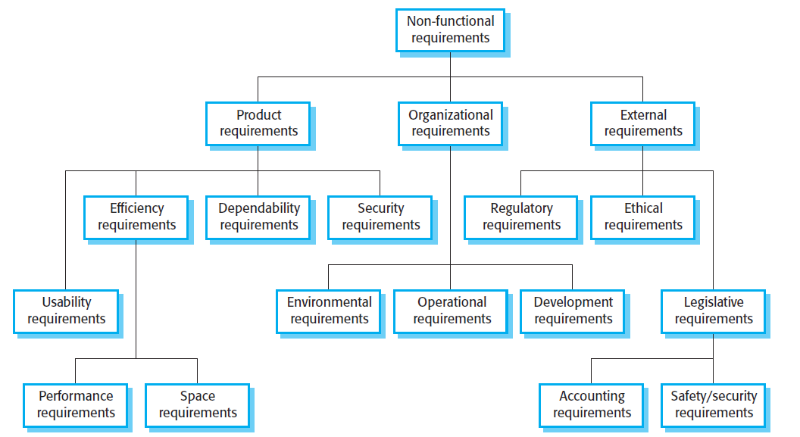

Figure 1 An example figure

## Performance Requirements

<If there are performance requirements for the product under various circumstances, state them here and explain their rationale, to help the developers understand the intent and make suitable design choices. Specify the timing relationships for real time systems. Make such requirements as specific as possible. You may need to state performance requirements for individual functional requirements or features.>

ID: NF1

TAG: Response Time < ID: FR6 TITLE: Mobile application - Search >

GIST: The fastness of the search

SCALE: The response time of a search

METER: Measurements obtained from 1000 searches during testing.

MUST: No more than 2 seconds 100% of the time.

WISH: No more than 1 second 100% of the time.

ID: NF2

TAG: Response Time for < ID: FR4 TITLE: User log-in - Mobile application >

GIST: The fastness of the search

SCALE: The response time of a search

METER: Measurements obtained from 1000 searches during testing.

MUST: No more than 2 seconds 100% of the time.

WISH: No more than 1 second 100% of the time.

## Safety Requirements

<Specify those requirements that are concerned with possible loss, damage, or harm that could result from the use of the product. Define any safeguards or actions that must be taken, as well as actions that must be prevented. Refer to any external policies or regulations that state safety issues that affect the product’s design or use. Define any safety certifications that must be satisfied.>

## Security Requirements

<Specify any requirements regarding security or privacy issues surrounding use of the product or protection of the data used or created by the product. Define any user identity authentication requirements. Refer to any external policies or regulations containing security issues that affect the product. Define any security or privacy certifications that must be satisfied.>

## Software Quality Attributes

<Specify any additional quality characteristics for the product that will be important to either the customers or the developers. Some to consider are: adaptability, availability, correctness, flexibility, interoperability, maintainability, portability, reliability, reusability, robustness, testability, and usability. Write these to be specific, quantitative, and verifiable when possible. At the least, clarify the relative preferences for various attributes, such as ease of use over ease of learning.>

## Business Rules

<List any operating principles about the product, such as which individuals or roles can perform which functions under specific circumstances. These are not functional requirements in themselves, but they may imply certain functional requirements to enforce the rules.>

# Other Requirements

<Define any other requirements not covered elsewhere in the SRS. This might include database requirements, internationalization requirements, legal requirements, reuse objectives for the project, and so on. Add any new sections that are pertinent to the project.>

# References

For the references you can use programs like Zotero (https://www.zotero.org/)

Object-Oriented Software Engineering, Using UML, Patterns, and Java, 2nd Edition, by Bernd Bruegge and Allen H. Dutoit, Prentice-Hall, 2004, ISBN: 0-13-047110-0.

# Appendix A: Glossary

<Define all the terms necessary to properly interpret the SRS, including acronyms and abbreviations. You may wish to build a separate glossary that spans multiple projects or the entire organization, and just include terms specific to a single project in each SRS.>